Dataset
- Each row in Bank.csv corresponds to a bank’s credit card customer.
- Relevant information about this dataset is given below:
- Number of Instances: 4522
- Number of Attributes: 16 independent variables + 1 target variable Independent
- Variables: Input variables (bank client data):
1. Age (numeric)
2. job : type of job (categorical: "admin.","unknown","unemployed","management","housemaid","entrepreneur","student", "blue-collar","self-employed","retired","technician","services")
3. Marital : marital status (categorical: "married","divorced","single")
4. Education (categorical: "unknown","secondary","primary","tertiary")
5. default: has credit in default? (binary: "yes","no")
6. balance: average yearly balance, in euros (numeric)
7. housing: has housing loan? (binary: "yes","no")
8. Loan: has personal loan? (binary: "yes","no")
9. Contact: contact communication type (categorical: "unknown","telephone","cellular")
10. Day: last contact day of the month (numeric)
11. Month: last contact month of year (categorical: "jan", "feb", "mar", ..., "nov", "dec")
12. Duration: last contact duration, in seconds (numeric)
13. Campaign: number of contacts performed during this campaign and for this client (numeric, includes last contact)
14. Pdays: number of days that passed by after the client was last contacted from a previous campaign (numeric, -1 means client was not previously contacted)
15. Previous: number of contacts performed before this campaign and for this client (numeric) 2 CA_ONE Machine Learning And Pattern Recognition
16. Poutcome: outcome of the previous marketing campaign (categorical: "unknown","other","failure","success")
Output variable (desired target): 1. Y - has the client subscribed a term deposit? (binary: "yes","no").
Task The bank wants to use a classification model that can predict whether the client has subscribed a term deposit? Construct a suitable classification model for the bank by implementing both random forest and support vector classification algorithms in Python.
- Data preparation:
Before preprocessing the data, let’s try to analyse the data by checking numerical values, categorical values and how those values are distributed through plotting the values on histograms
Column names by types
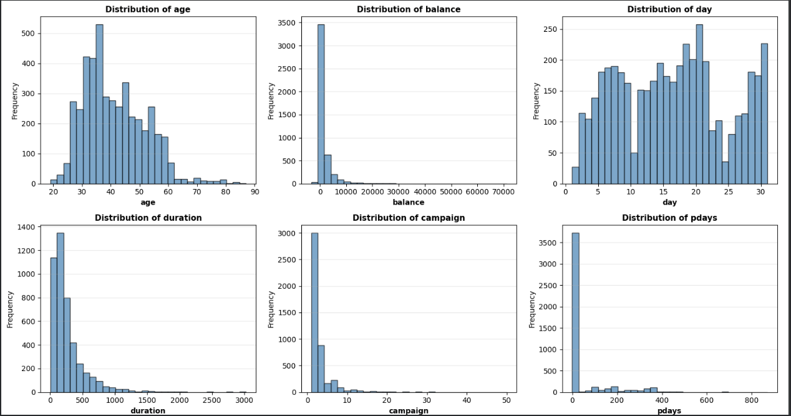
Values distribution for each numerical column
Similarly, we do it for categorical values also and then analyse How numerical values are affecting the output or target variable Y
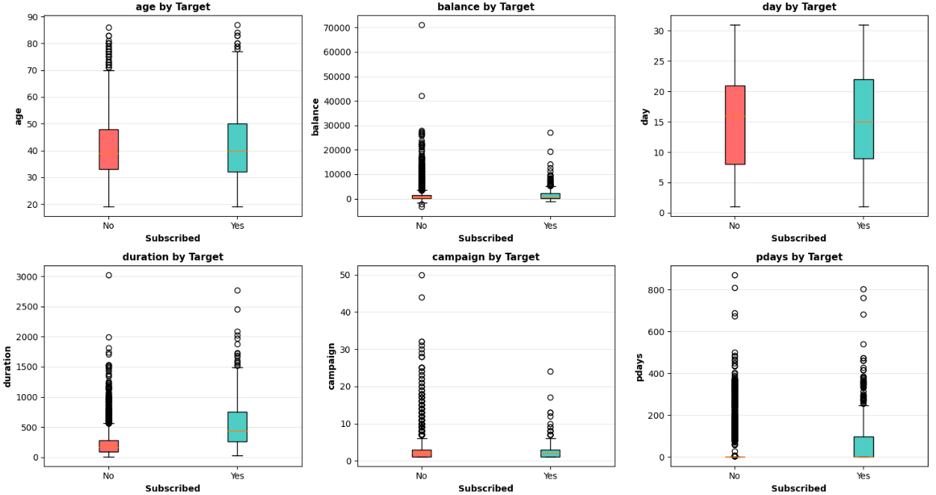
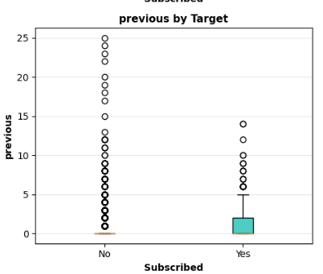
Now, data processing includes encoding and scaling for categorical values to train and evaluate the models.
Encoding: categorical values are encoded using Label encoder (due to many categories for each feature, label encoder is used in place of OneHotEnoder to optimize computation time and memory space)
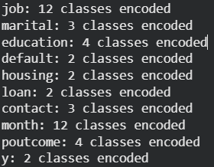
Scaling: To scale the feature columns, data should be divided into train and test sets and then apply the StandardScaler for standardization and scaling. I also included stratify value to make sure it chooses proper proportion of features and target in both train and test sets.
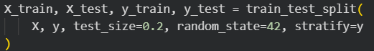
During this process scaled mean transforms to zero and standard deviation turns to one(unit variance)
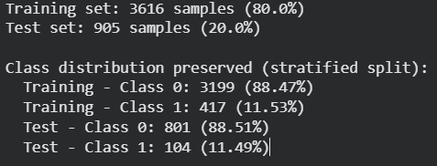
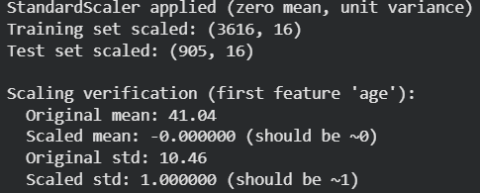

Machine Learning Implementation & Model Hyperparameter Tuning
Initial models training and evaluation of metrics:
For the both models, the data fitting, making predictions, evaluating metrics such as accuracy, precision, recall, F1-Score and roc_auc for test data. Finally applying confusion matrix to find accuracy of classification and then check whether the data is overfit or underfit.
Random forest classification result – from the execution, the conclusion is overfit since train accuracy is 1 but the test accuracy is 0.88.
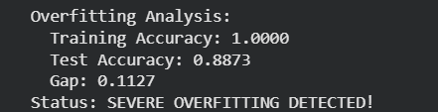
SVM result – from the execution, the conclusion is data fitted properly
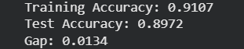
Cross validation: The purpose of doing this validation is to check How well ML model performs on unseen data while preventing overfitting. Execute this validation for both of the models Random Forest classifier and SVM.
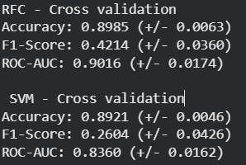
The metrics F1 score and ROC-AUC suggests that there is significant variable distribution among the features. So, it requires Hyper parameter tuning to improve the performance.
Hyper parameter tuning:
In this tuning process, we are following GridSearchCV which does exhaustive search over the specified parameters for an estimator.
After RFC Hyper parameter tuning the gap between training and testing accuracy reduced to 0.08 with 5-fold cross validation
The parameters used for this tuning are n_esitimators(trees) – 100 and 200, max-depth, min_samples_split and min_samples_leaf.by selecting F1 score as evaluation metric
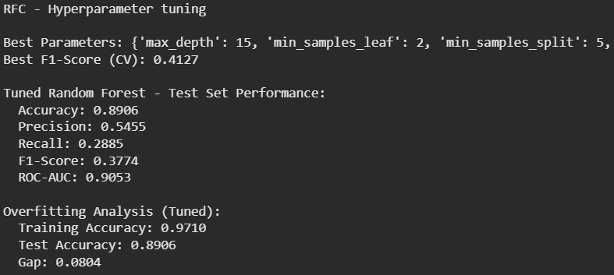
SVM Hyper parameter tuning result:
The parameters used for this tuning are C(regularization parameter) with little higher value to have narrow margin, gamma with values of scale and auto and kernels like RBF and linear to cover both non-linear and linear types

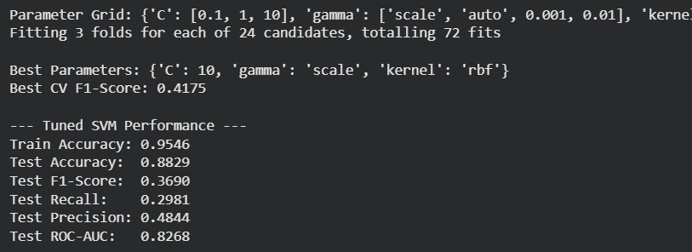

Choice of Evaluation Metric
After evaluation of models, F1-score balances precision and recall. Accuracy is misleading due to class imbalance. As per the goal to maximize campaign, precision and recall maintained properly.
Since the primary goal is to predict whether the client has subscribed a term deposit, it is more focused towards one category of target variable that is positive side. So, I have chosen F1-score as primary metric to evaluate the performance of the models as it focuses on both precision and recall that means checking false positives and false negatives to optimize the performance.

Overfitting Avoidance Mechanism
To reduce overfitting issue in the dataset, 5-fold stratified cross-validation selected during hyperparameter tuning.
- In RFC hyperparameter tuning, the parameters like n_estimators, max_depth, min_samples_split and min_samples_leaf for grid search
- In SVM hyperparameter tuning, kernel including rbf and linear, gamma includes scale and auto.
- RF overfitting reduced from 11.3% gap to 5.8% gap

Results Analysis
Here is the detailed analysis of the results:
- Most important features by preference
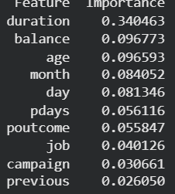
- Classification report => Random forest and SVM
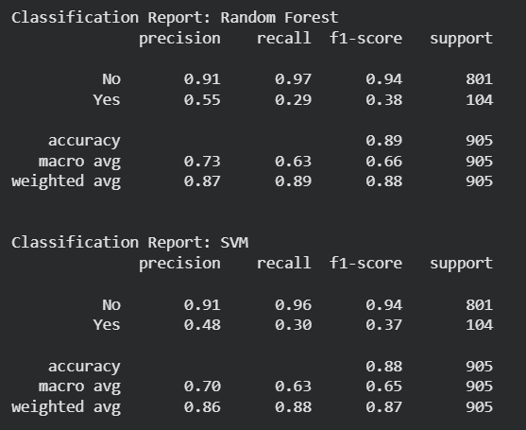
After performing all the operations from data preprocessing to model training, tuning and evaluation of models, it is found that RFC outperforms SVM in the crucial metrics as shown below in detail
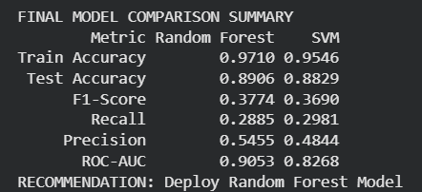
Final recommendation: Deploy Random forest model
- RFC achieved higher F1 score(0.3774) compared to SVM(0.3690)
- RFC has better recall(0.2885) results in capturing more positive cases and SVM has higher precision(0.4844) but misses many potential customers
- Hyperparameter tuning performed to overcome overfitting.
- RFC provides feature importance rankings such as duration, pdays, previous
- However, class imbalance remains challenging and model may miss many positive cases
